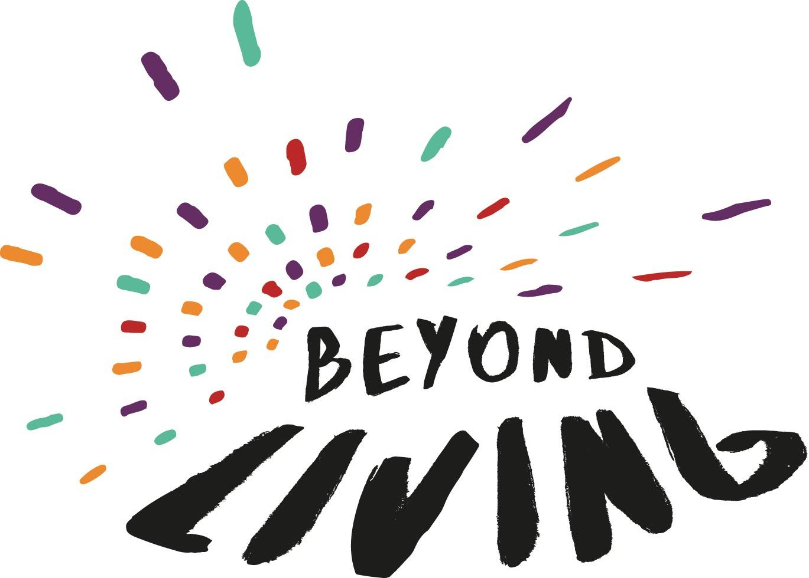

GNP+, ICW and Y+ Global
Life Force for Beyond LIVING Application Form

All questions below have a 300-word limit suggestion.

1. Why do you want to be a member of the Life Force (explain your motivation in joining this group)? Please include any life experiences that you think are relevant to Beyond LIVING

2. What issues are you passionate about? Describe some of the advocacy you are involved in.

3. How would you benefit from being a member of the Life Force (what do you think you will get out of this experience)?

4. List any committees or advisory groups (local, national, global) that you are a member of:

Please provide contact details of two referees:

Name:
Organization:
Country:
Contact Details:
How you know each other:

Name:
Organization:
Country:
Contact Details:
How you know each other:

Please tick to confirm that you have read the Beyond Living Call for Applications and are able to devote the time and energy needed for Beyond LIVING:

Yes No

Essential Information
Name:
Email address:
WhatsApp:
Gender identity:
Nationality:
Country and city you live in:

How to Apply
Send completed application to beyondliving@gnpplus.net email by February 14th, 2021 please put Life Force Application in the subject title.

Please note no CVs or letters will be considered – all applications must use the form provided.

We want you to know that we appreciate the time and energy that you put into your application. Shortlisted candidates will be contacted by March 1st and may be asked a few questions for clarification. Thank you once again!

